**PROJECT DESIGN PHASE-1**

**PROBLEM SOLUTION FIT**

|  |  |
| --- | --- |
| Date | 30 SEPTEMBER 2022 |
| Team ID | PNT2022TMID15455 |
| Project Name | Early Detection of Chronic Kidney Disease Using Machine Learning |
| Maximum Marks | 2 Marks |

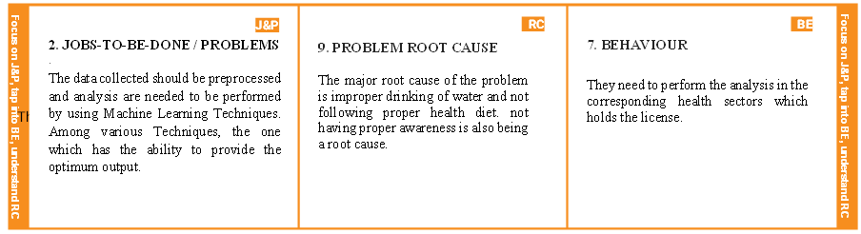**Problem Solution Fit:**